 |  | Michigan Department of Natural Resources – Forest Resources Division  Cooperative Beech Bark Disease  Resistance Survey  This information is requested under the authority of  the Department of Natural Resources. |  |  |  |  |  |  |  |  | MSU Tag #
 |  |  |  |  |  |  |  |  |  |  | Date
Observer
Name |  |  |  |  |  |  | Organization
Address |  |  |  |  |  |  | Telephone  ( )
City, State, ZIP |  |  |  |  |  |  | E-mail
Landowner
Name |  |  |  |  |  |  | Organization
Address |  |  |  |  |  |  | Telephone  ( )
City, State, ZIP |  |  |  |  |  |  | E-mail
Land Use
Residential Recreation Area Private Non-Industrial Federal State
Site Location
County |  |  | Political Township |  |  |  |  |  | TRS Q. Sec
GPS Coordinates (preferred) (NAD83; Lat./Long. in decimal degrees) (Lat. 45.71717 / Long. -85.12343)

Tree Data
DBH (inches): / Scales: Absent; Sparse/Date Resistance Observed:
Tree Condition
Healthy
Unhealthy (describe e.g. % Dieback, Discoloration):
Site and Diagnostic Data
Beech Component of Area |  |  |  |  |  |  | Condition of Beech in Area
<21% beech stems |  |  |  |  |  |  | Scales only
21-40% beech stems |  |  |  |  |  |  | Scales and Nectria cankers
>40% beech stems |  |  |  |  |  |  | Beech Bark Disease (BBD) induced decline/mortality
Distance to nearest scale infested trees |  |  |  |  |  | feet | Major Overstory Species:
Candidate trees must be
- > 9" in diameter at breast height  - Adjacent to trees heavily infested by beech scale, or residual beech in a BBD aftermath forest.  - Free of scales, or scales have remained scarce for  > 1 year. |  |  |  |  |  |  |  |  | 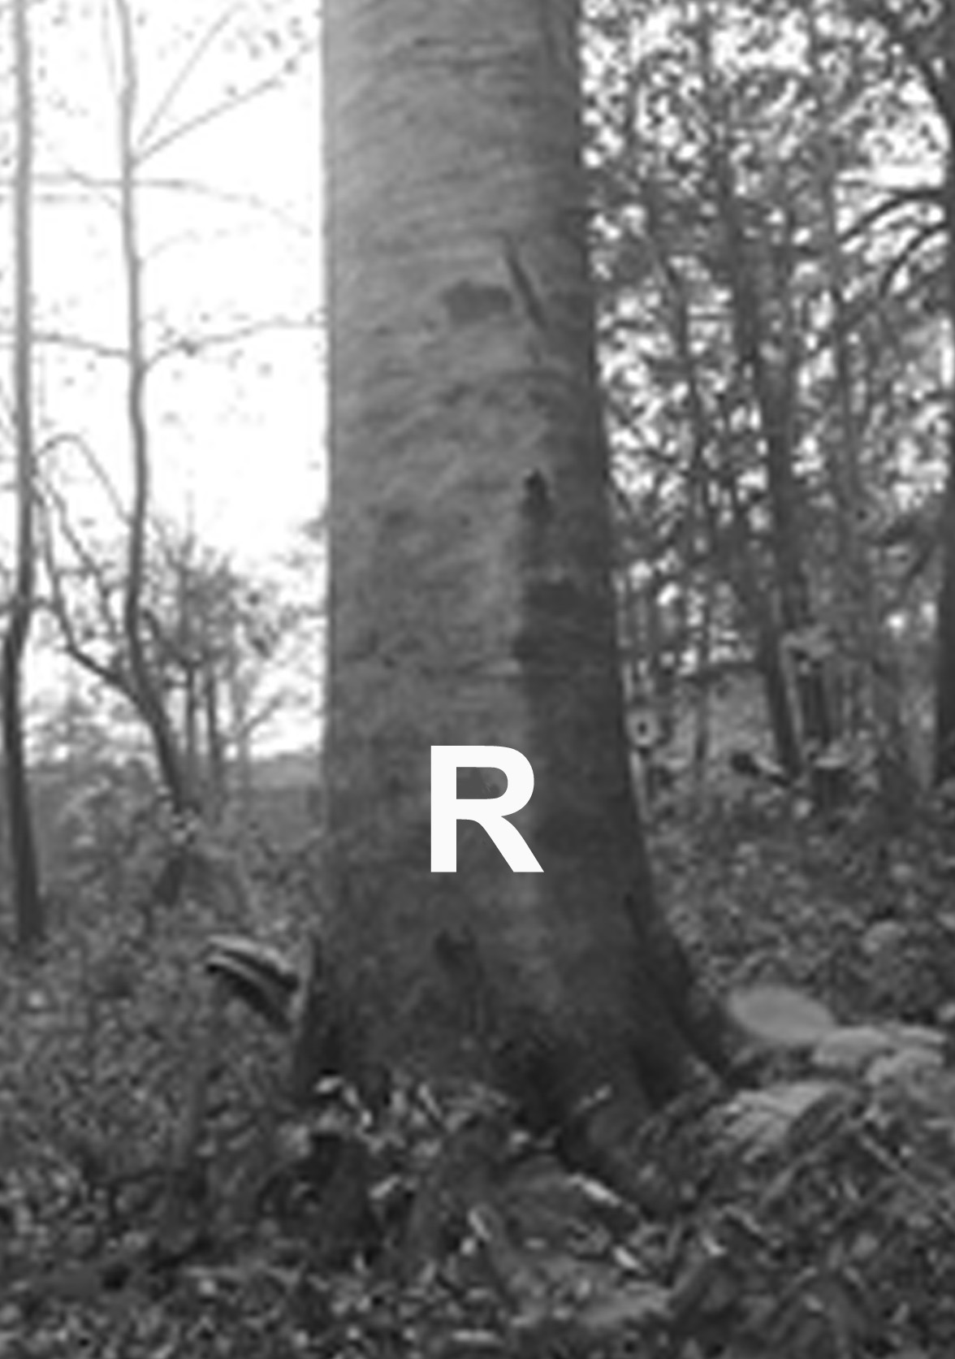
Please sketch tree location on
Mapping Area on the back of this survey and
provide comments necessary to find candidate tree.
Mark resistant trees with an “R” on two
sides of the tree. Use white tree marking paint.
Draw detailed sketch showing the location of the candidate tree. Include significant landmarks and distances using selected map scale. Use comment box to add useful directions or comments relative to tree selection, stand history, etc.
 |  |  |  |  |  |  |  |  |  |  |  | N↑
Scale: 3/4 inch = feet, yards, chains, miles (select one)
Comments: (One form can be used to report multiple trees on the same site. This may occur if a resistant clone is mapped, or if several separate candidate trees exist in the same proximity.)

Send completed surveys to:
Robert Heyd - Forest Health Management Program
Forest Resources Division
Michigan Department of Natural Resources
1990 US 41 South
Marquette, MI 49855

Telephone: (906) 228-6561
Email: heydr@michigan.gov

